Bolton Lads & Girls Club Employment Application Form 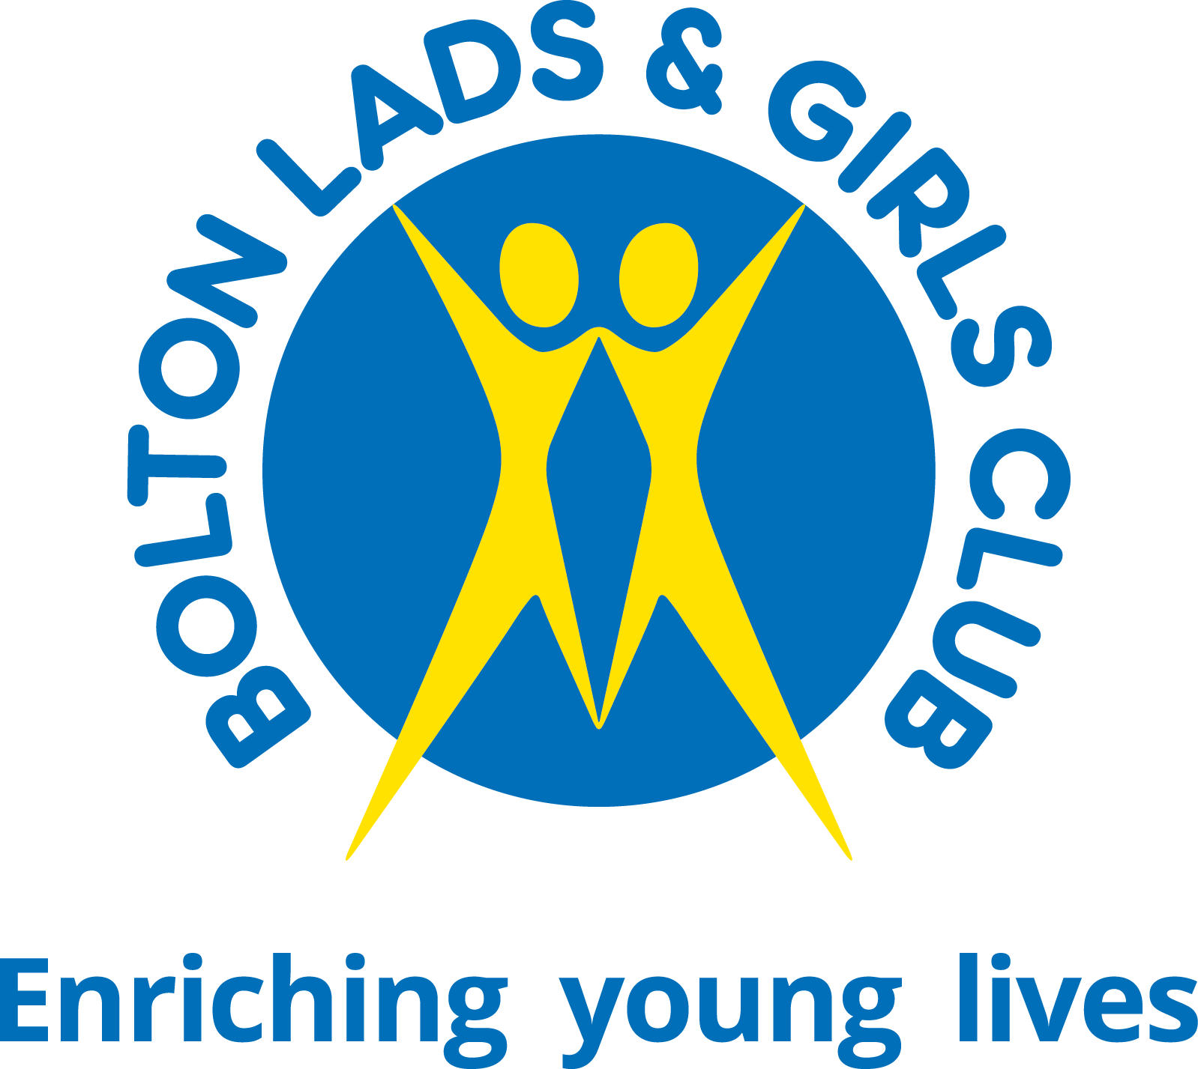

Applicant Reference No: ________________ (for internal use)

PRIVATE & CONFIDENTIAL

Please complete all sections of the application form, if completing electronically please save the application as your full name and send to recruitment@blgc.co.uk. Please include in the subject title the job title of the post you have applied for and your full name. Please note CVs will not be accepted. Applications received after the closing date and time will not be considered.

PART A: PERSONAL INFORMATION
Position applied for:

Surname: |  | Title:
Preferred First Name:
Names in full:
Address (including postcode):
Phone (for us to contact you):
Email:
Are you eligible to work in the UK?
(Successful candidates will be required to provide documentary evidence before a job offer is confirmed)
Where did you see the vacancy advertised?

PART B: PERSONAL PROFILE
Please summarise in no more than 200 words, why you believe you are suited to this position. (You will be able to expand on your experience, competencies and qualifications in Parts C, D and E).

PART C: EDUCATION & TRAINING
Based on the Person Specification, please list your education, training, any relevant professional qualifications and membership of professional organisations below.

Date | Subject | Awarding Body | Qualification/Grade
Please continue on an additional sheet if necessary (or extend table)

PART D: EMPLOYMENT HISTORY
Starting with your current/most recent employment, please provide the details required in each column

Dates  Start & Finish | Employer  Name & Address | Job Title, Main Responsibilities  Major Achievements | Final Salary, Reason for Leaving
PART E: INFORMATION TO SUPPORT YOUR APPLICATION
Looking at the role profile, please explain how your skills, knowledge and experience meet the requirements of the job role. Additionally, please add any further relevant information to support your application.
PLEASE LIMIT YOUR RESPONSE TO ONE PAGE.
PART F: REFERENCES
Please give the names and addresses of Three people whom we may contact for a reference. Please note that Bolton Lads and Girls Club reserves the right to contact any of your former employers. References given should cover the last 5 years of your employment. The first references must be your present employer. If you are unemployed, this should be your last employer, or if this is your first job, your headteacher or college tutor. Personal references (e.g. from your GP or friends) are not acceptable.
 | CURRENT EMPLOYER | SECOND EMPLOYER / EDUCATION REFERENCE | CHARACTER REFERENCE
Name:
Job title:
Organisation:
Address:
Phone:
Email:

How do you know your second referee?
Can we take up your references before interview?

PART G: GENERAL

REHABILITATION OF OFFENDERS ACT 1974
Owing to the nature of the work, the youthwork profession is exempt from the previous provisions of the above Act. Therefore, applicants are not entitled to withhold information about cautions or convictions which for other purposes are ‘spent’ under the provisions of the Act. Bolton Lads and Girls Club has the facility to check for cautions and convictions.
Have you at any time been cautioned or convicted of a criminal offence?
If ‘Yes’, please give details in strict confidence.
If completing this form at a job fair, please ask for an envelope so that your application can be sealed.
How did you find out about this position?
Do you hold a current full driving licence?
How long have you held this licence?
Please give details of current endorsements or driving convictions:
If appointed, how soon could you join us?

PART H: DECLARATION

I confirm the information given on this form is correct and complete. I acknowledge that misleading statements may be grounds for cancelling any agreements made. I understand that an Enhanced Disclosure will be sought in the event of a successful application.
Signed: |  | Date:

If you are sending this form electronically, you will be asked to sign it if you are invited for interview.
Please submit your application as a Microsoft Word (or similar) document. Please don’t submit as a PDF. Thank you for your interest in Bolton Lads & Girls Club and for taking the time to complete the application for this post. If you have not heard from us within a week of the closing date then your application has not been shortlisted.

